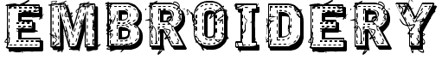
MATERIALS:
- Embroidery Hoop: A wooden frame that holds the fabric taught for sewing
- Darning Needle: Sewing needle with a wide-eye to hold floss
- Embroidery Floss: Thicker version of thread used for embroidery
- Fabric: Natural fabrics work well for embroidery like cotton or denim
- OPTIONAL: Iron-on sewing pattern, draw directly on fabric or create online

TUTORIALS:
SPLIT STITCH | FRENCH KNOT | SPIDER WEB | BASKET WEAVE | HERRINGBONE
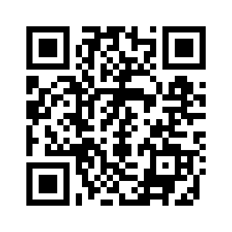 | 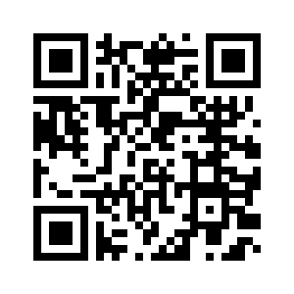 | 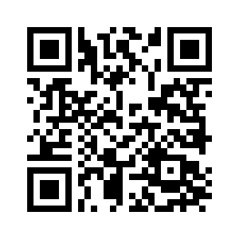 | 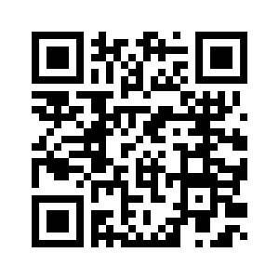 | 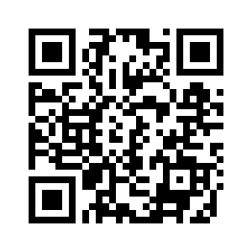
CHAIN STITCH | BUTTON HOLE | INNERLACED | FISHBONE | PLAYLIST
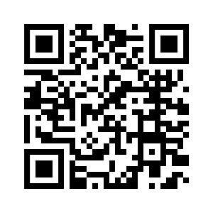 | 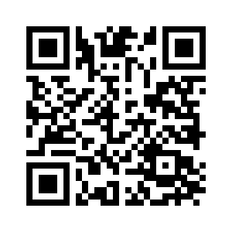 | 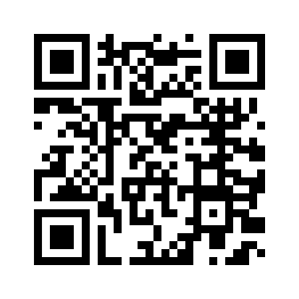 | 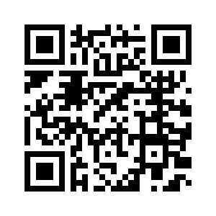 | 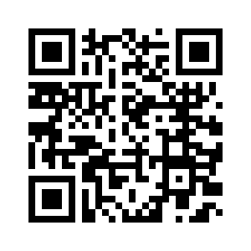

Mary Courbet
Red Ted Art

TIPS:
- Always start and end on the BACK of your work to hide you knots
- Wet your thread (with water or mouth) to thread the needle easier
- Use the tip of your needle to pick out knots in the thread

OVERALL GOAL:
Create an embroidered artwork of your choice in both content and style but that also adheres to the following rubric components:
Product/Performance  Skills & Techniques  Embroidery Stitching | Sampler includes 7 or more stitch styles; organized very well | Sampler has 5 or more stitches represented in an organized fashion | Sampler includes 4 or more stitches mostly organized well | Sampler has 3 or fewer stitches on the sampler that are not organized well | Sampler has 2 or fewer stitches explored and they are un-organized
Product/Performance  Stitching Quality | Craft and care are exceptional; stitches are even and backing is knotted properly | Craft and care are evident; student attempts evenness and clean knots. | Craft and care is lacking; backing is untidy; stitches are slightly uneven | Minimal care and craft; stitches are erratic and back is sloppy | Craft and care are not evident; or product is UNFINISHED

