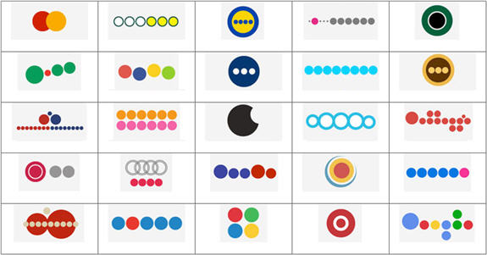

MasterCard/Subway/Ikea/T-Mobile/Starbucks 7-Up/eBay/GAP/Twitter/UPS
American Airlines/Dunkin Doughnuts/Apple/Skype/Kelloggs LG/Audi/FedEx/Burger King/Flickr
Budweiser/Mobile/Windows/Target/Google

